**Smart City Waste Management CRM**

**PHASES 5-9**

**Phase 5: Apex Programming (Developer)**

* Classes & Objects (e.g., PickupRequestHelper, TruckAssignmentHelper)
* Apex Triggers (before/after insert/update/delete on Pickup_Request__c)
* Trigger Design Pattern (use PickupRequestHandler for clean code)
* SOQL (query Pickup Requests, Trucks)
* SOSL (search Pickup Requests by Address)
* Collections: List, Set, Map (store and process requests/trucks)
* Control Statements (if/else, for loops, while)
* Batch Apex (bulk update request statuses)
* Queueable Apex (Google Maps Distance/ETA updates)
* Scheduled Apex (daily reminders for collectors)
* Future Methods (async external API calls)
* Exception Handling (try–catch for errors)
* Test Classes (≥75% coverage for triggers and classes)
* Asynchronous Processing (queueable, future, scheduled jobs)
* 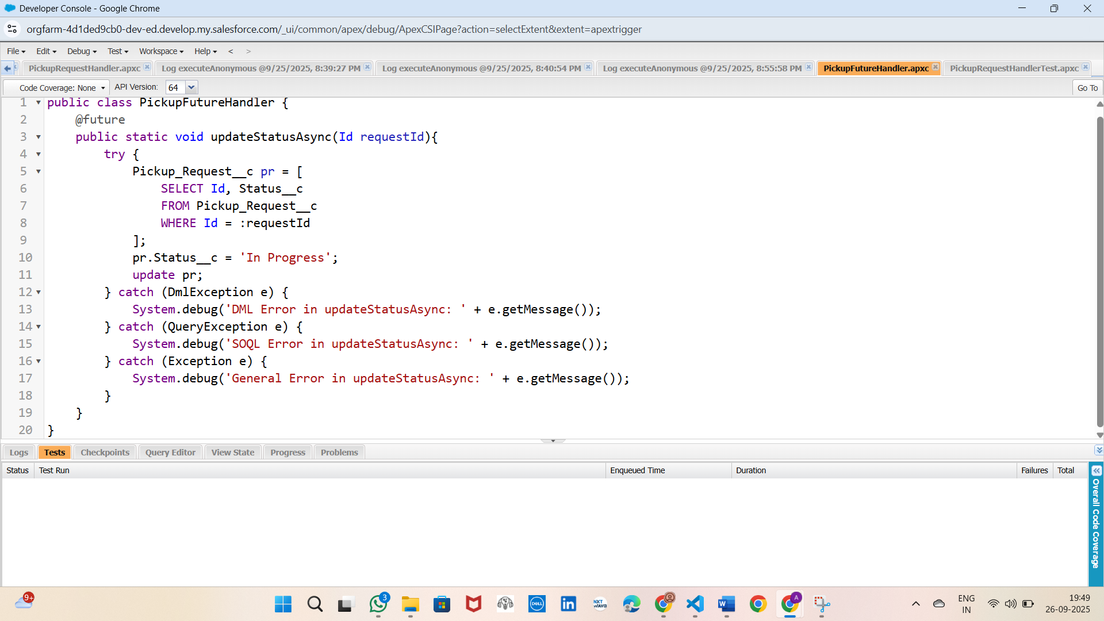

**Phase 6: User Interface Development**

* Lightning App Builder (customize Smart City Waste App)
* Record Pages (Pickup Request):
  + Left: Pickup Date/Time, Status
  + Right: Assigned Collector, Address, Estimated Weight
  + Related List: Trucks, Tasks
* Tabs: Pickup Requests, Trucks, Recycling Plants
* Home Page Layouts (KPIs, Quick Links, Reports)
* Utility Bar (Notes, Recent Items)
* LWC (Lightning Web Components):
  + pickupRequestsToday → list today’s requests
  + Action Button → “Mark as Completed”
* Apex with LWC (imperative Apex calls for updates)
* Events in LWC (CustomEvent → parent communication)
* Wire Adapters (@wire → auto fetch data)
* Imperative Apex Calls (button actions, record updates)
* Navigation Service (navigate from LWC to Pickup Request record)

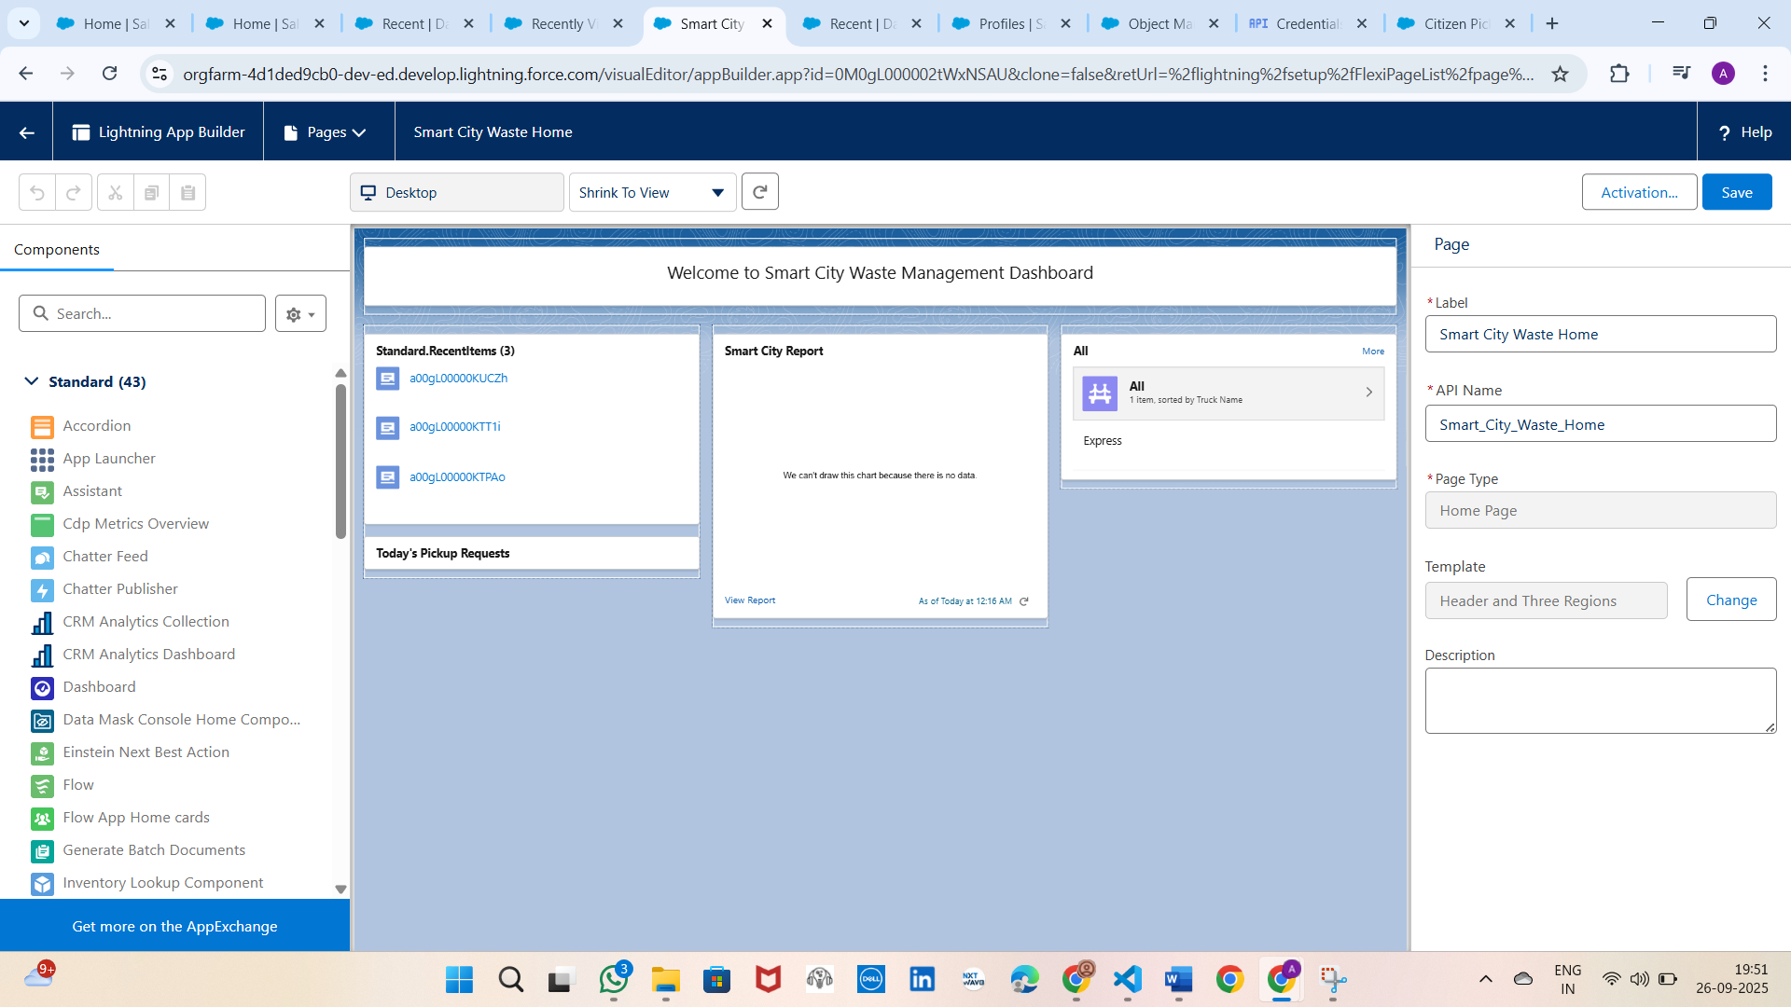

**Phase 7: Integration & External Access**

* Named Credentials → GoogleMapsAPI (https://maps.googleapis.com)
* External Services → Connect Google Directions API
* Web Services (REST) → Apex callouts to Google Maps
* Callouts → GoogleMapsService class (directions, distance, ETA)
* Platform Events
* Change Data Capture (track Pickup Requests changes)
* Salesforce Connect (optional external system integration)
* API Limits (monitor governor limits & API usage)
* OAuth & Authentication (secure integrations if needed)
* Remote Site Settings (if not using Named Credential)

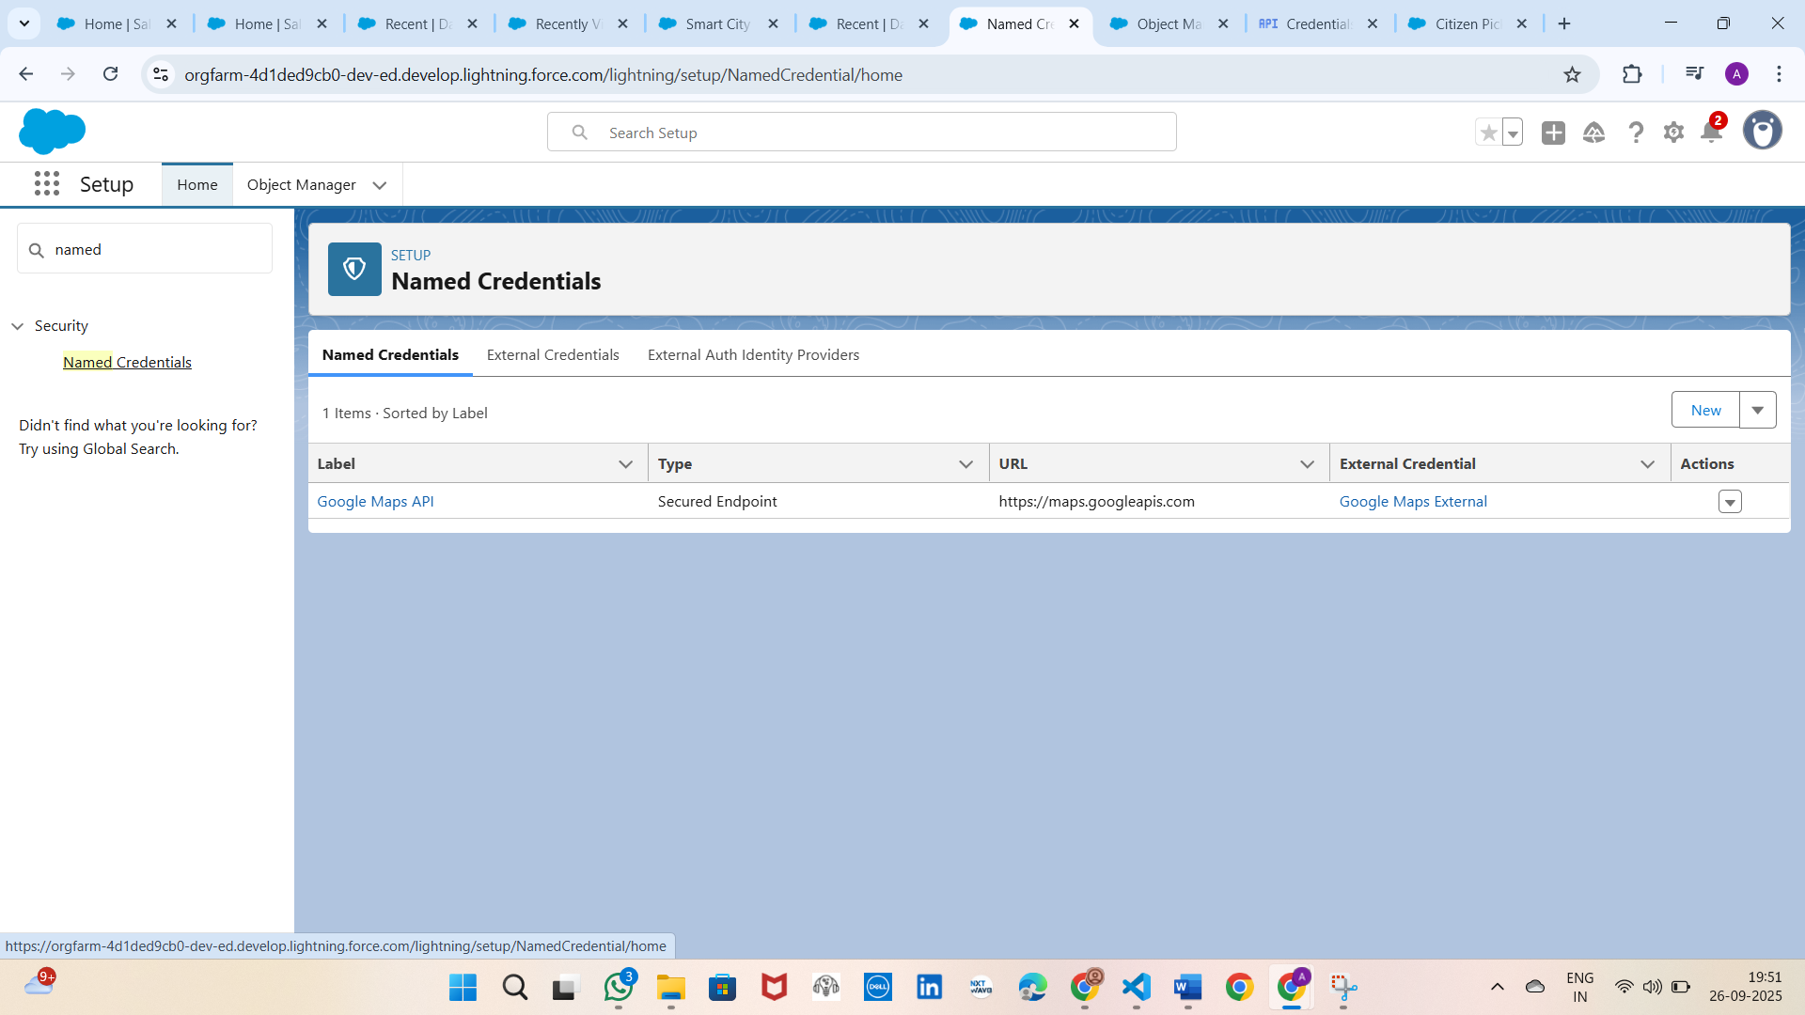

**Phase 8: Data Management & Deployment**

* Data Import Wizard (load Citizens, Collectors, Trucks, Plants)
* Data Loader (bulk import/export requests, trucks)
* Duplicate Rules (prevent duplicate Pickup Requests)
* Data Export & Backup (weekly backup schedule)
* Change Sets (migrate flows, fields, profiles)
* Unmanaged vs Managed Packages (share as unmanaged for demo)
* ANT Migration Tool (advanced deployments)
* VS Code & SFDX (source-driven deployments)

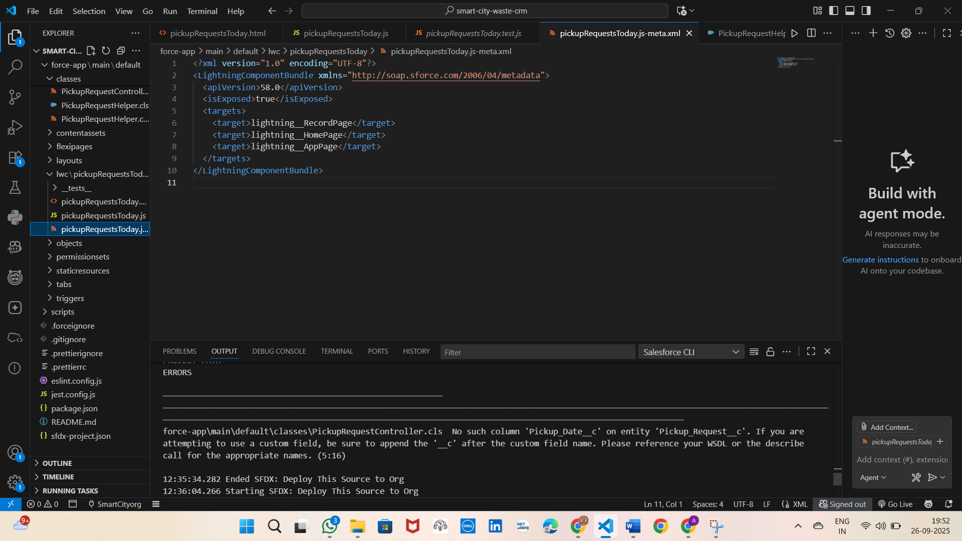

**Phase 9: Reporting, Dashboards & Security Review**

* Reports:
  + Tabular → Simple list of requests
  + Summary → Requests by Status
  + Matrix → Requests by Collector and Status
  + Joined → Compare Requests with Plant Load
* Report Types → Pickup Requests with Trucks & Recycling Plants
* Dashboards:
  + Pie Chart → Requests by Status
  + Bar Chart → Requests per Collector
  + Gauge → Plant Utilization %
  + Table → Recent Requests
* Dynamic Dashboards (role-based visibility)
* Sharing Settings (OWD, Role Hierarchy, Sharing Rules)
* Field Level Security (hide fields from Citizens, allow for Officials)
* Session Settings (session timeout = 2 hrs)
* Login IP Ranges (restrict access, optional)
* Audit Trail (track configuration changes)

